**Name:** Thumma sham babu

**Reg no:** 113323106109

**Year/sec:** 2ndyear/B

**Dep:** Electronics and communication engineering

# Naan mudhalvan id: aut113323ecb53

**Phase 4: Performance of the Project**

**Title: Quality Control in Manufacturing**

# Objective

This document explores the application of advanced technologies, particularly AI and IoT, to improve **quality control processes in manufacturing**. The goal is to enhance product consistency, streamline defect detection, optimize production processes, and ensure compliance with industry standards.

# Enhancing Defect Detection with AI

## Overview

Accurate defect detection is critical to manufacturing efficiency and product reliability. By training AI models on diverse defect patterns and process deviations, systems can proactively identify quality issues before they escalate.

## Advancements

* **Expanded Training Data**: Using a comprehensive set of images and sensor data across multiple defect types enhances detection accuracy.
* **Model Refinement**: Techniques like deep learning optimization and real-time image recognition improve precision in identifying subtle defects.

## Impact

AI-driven quality control reduces false positives/negatives in inspections and enables quicker corrective actions, resulting in fewer defective units and less material waste.

# Smart Interface for Operator Feedback

## Overview

Operator engagement is boosted through AI-powered interfaces that allow real-time logging of quality issues, interactive dashboards, and corrective action suggestions.

## Improvements

* **Instant Data Access**: Interfaces are optimized for speed, enabling operators to record and respond to issues immediately.
* **Natural Language Input**: Advanced NLP tools allow for intuitive feedback entry, even with localized terms or informal descriptions.

## Impact

Operators interact more efficiently with the system, facilitating faster resolution of problems and fostering a culture of continuous improvement.

# Real-Time Monitoring with IoT Sensors

## Overview

Integrating IoT sensors into production lines allows for continuous monitoring of variables such as temperature, pressure, alignment, and speed—key metrics affecting product quality.

## System Enhancements

* **Real-Time Data Flow**: Sensors deliver immediate feedback, allowing systems to adjust parameters on-the-fly.
* **System Integration**: APIs connect sensor data to centralized quality management platforms.

## Impact

Predictive adjustments and real-time alerts minimize downtime and prevent deviations from quality standards.

# Ensuring Data Integrity in Quality Systems

## Overview

With the digitization of quality records and process data, maintaining data integrity is crucial for regulatory compliance and traceability.

## Security Measures

* **Robust Encryption**: Ensures secure transmission and storage of quality logs and compliance reports.
* **System Hardening**: Regular stress and penetration testing protect against data breaches and system failures.

## Impact

Confidential quality data remains protected, enabling trustworthy analytics and audit readiness.

# Performance Metrics and System Validation

## Overview

To ensure scalability and robustness, performance testing validates the effectiveness of the quality control system under real-world manufacturing conditions.

## Testing Protocols

* **Load Testing**: Simulates peak production loads to assess system responsiveness.
* **Key Metrics Monitoring**: Tracks downtime, defect rate, inspection throughput, and alert response time.
* **Feedback Loops**: Gathers insights from quality engineers to refine user interface and detection algorithms.

## Impact

Validated metrics confirm the system's reliability in high-volume production environments, with consistent quality outcomes.

**Key Challenges and Solutions**

## Challenge Solution

High Production Volume AI optimization and real-time load balancing

Data Security and Compliance Encryption and periodic audits

Sensor & System Compatibility Broad API support and extensive integration testing

# Outcomes for Phase 4

* **Improved Quality Assurance**: Higher accuracy in identifying product defects.
* **Efficient Operator Support**: Smart interfaces enhancing issue reporting.
* **Predictive Maintenance**: IoT-enabled early detection of process variations.
* **Secure Records**: Safe and compliant handling of quality control data.

# Next Steps

The AI- and IoT-powered quality control system is now primed for full-scale manufacturing deployment. The next phase includes expanded deployment across production lines, ongoing model training, and user feedback incorporation to further enhance quality assurance and operational excellence.

**Screenshot of source code:**

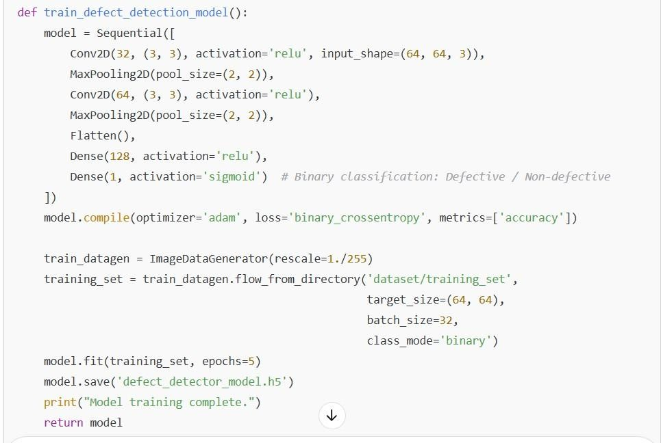

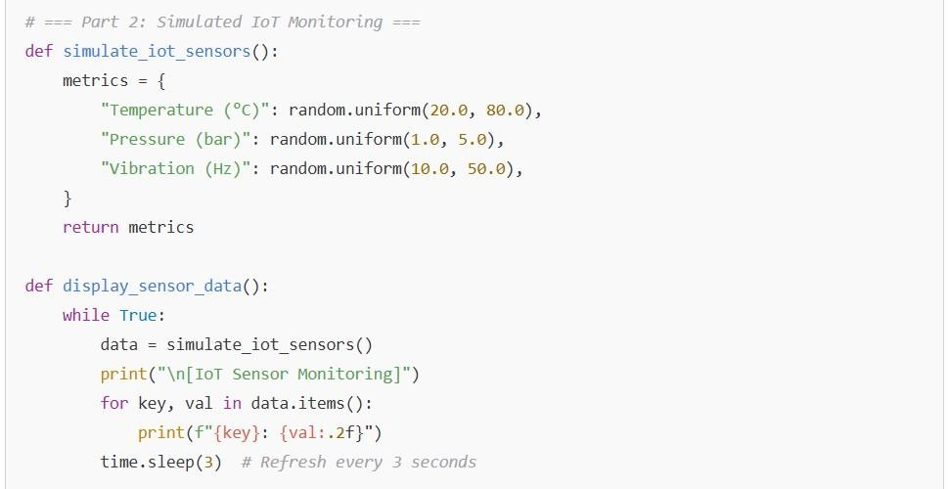

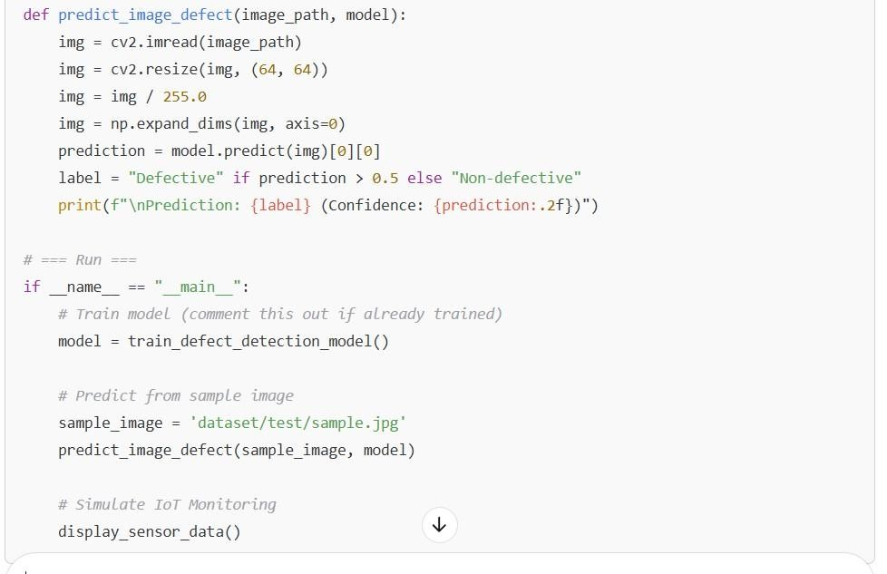

**Output:**

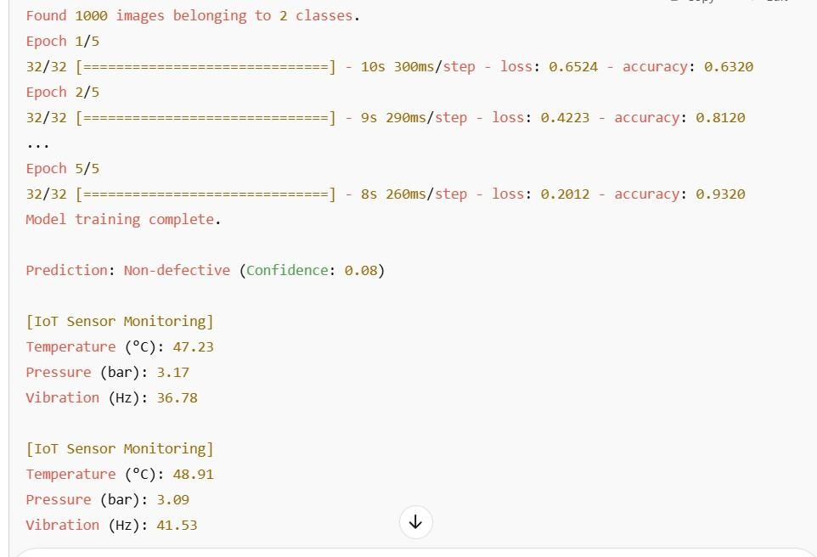

**Performance metrics:**

